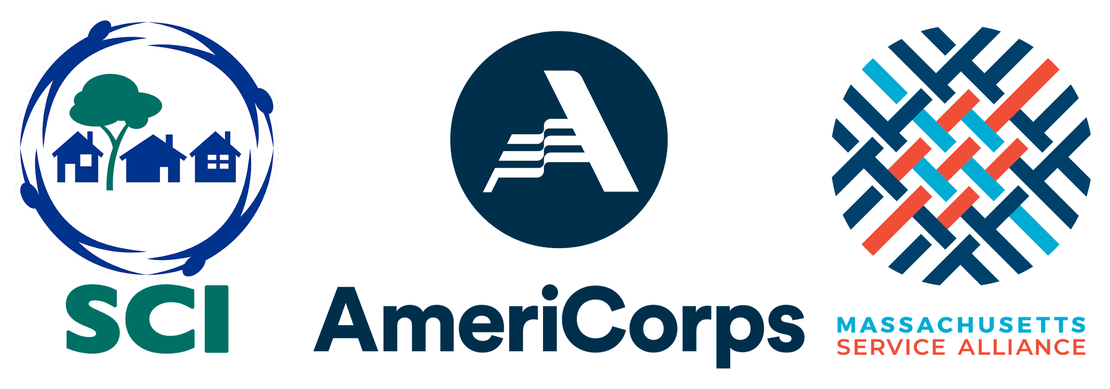

SCI AmeriCorps Member Service Position 2023-2024
Community Engagement Coordinator

The SCI AmeriCorps program supports youth success by connecting young people with the relationships, experiences, and resources they need to succeed. Members implement capacity building activities that increase volunteer participation, and provide leadership training and community service opportunities for youth. Since 2007, SCI AmeriCorps Members have served at various host sites in the Greater Boston area that are aligned with the mission of Social Capital Inc. (SCI).

SCI AmeriCorps is currently looking for candidates to fill positions for a 900-hour service term (approximately 40 hours/week) from late January 2024 through June 2024.

AmeriCorps Member Benefits - Standard

- Receive a Taxable Stipend of up to $24,000/year, paid bi-weekly
- Earn a Federal Education Award worth about $3,697.50 upon successful completion of service
- Eligible for Health Care at a no cost premium
- Can receive Student Loan Forbearance during active service

SCI AmeriCorps Member Benefits - Exclusive

- Free Enrollment in a Community Engagement course taught by Merrimack College faculty with the option to receive undergraduate or graduate academic credit!
- Free Access to Merrimack College campus resources via Merrimack Student ID!
- Free MBTA Link Pass or transportation or transportation stipend during your service term provided by SCI AmeriCorps!

HOST SITE OPPORTUNITY ~ Kids in Tech ~ Boston & Lowell, MA
Giving kids the skills they need to succeed in the 21st century and beyond, Kids in Tech’s mission is to educate, excite, and empower youth to utilize technology and foster a lifelong interest that will aid in their educational and employment possibilities. www.kidsintech.org.

At Kids in Tech, the SCI AmeriCorps Member core activities will be:

- Participate fully in KIT trainings, resulting in industry-approved certifications
- Mentor youth (ages 8-14 in two Boston public schools as an after-school KIT Tech Club junior instructor in STEM subjects and serve in the Lowell office once a week
- Help lead weekly meetings and activities of after-school Tech Clubs
- Assist with recruiting, training, organizing, and mobilizing volunteers
- Liaise between KIT and Lowell and Boston Public Schools to coordinate Tech Club activities

SCI AmeriCorps Member - Essential Requirements

- Commit to full term-of-service in local communities with diverse residents
- Serve in-person for some or all service activities
- Participate fully in all SCI AmeriCorps orientations, trainings, surveys and evaluations
- Complete a Social Capital Youth Project for host site partner youth enrichment programming
- Must be at least 18 years of age at time of enrollment

Submit your application through the form at bit.ly/servewithsci.
Please contact our Program Director with any questions at americorps@socialcapitalinc.org.

Reasonable accommodations will be provided as needed for applications, interviews and service. If you need an accommodation, please contact our Program Director at americorps@socialcapitalinc.org.

SCI AmeriCorps prohibits all forms of discrimination and harassment based on of race, color, ethnicity, national origin, gender, age, religion, sexual orientation, disability, gender identity or expression, marital or parental status, pregnancy, genetic information, military service/veteran status, political affiliation, and reprisal or retaliation for prior civil rights activity.

